Gr4vy Integration Document

SFRA Integration Guide

**Version <23.1.0>**

**Document Revision History**

| **Revision** | **Author** | **Date** | **Status and Description** |
| --- | --- | --- | --- |
| 23.1.0 | Prajith R | 15-05-2023 | Initial version |

Contents

1 Overview 5

2 Features 5

3 Limitations, Constraints 5

4 Compatibility 6

5 Installation 6

5.1. Cartridges 6

5.2. Metadata 6

5.2.1. Services 7

5.2.2. Payment Processor 7

5.2.3. Payment Methods 8

5.1.1 Jobs 8

6 Configurations 9

6.1. Custom Preferences 9

6.1.1 Gr4vy 10

6.1.2 Gr4vyTheme 12

6.2. Order Preferences 13

7 Gr4vy Webhook Notifications 14

8 Backoffice transactions 15

8.1.1 Capture 15

8.1.2 Refund 16

8.1.3 Void 17

9 Testing 17

9.1 Proceed to Checkout as Guest and Enter Shipping Information 17

9.2 Enter Billing Information and Payment Details 18

9.3 Placing Order 19

9.4 Confirmation Email 21

9.5 Check Order in Business Manager 22

9.6 Visit Gr4vy Dashboard to Confirm Order 23

10 Operations, Maintenance 24

10.1 Data Storage 24

10.1.1 Custom Cache 24

10.2 Availability 25

10.3 Failover / Recovery Process 25

10.4 Support 25

11 Appendix 25

11.1 System Extensions 25

11.1.1 Basket 25

11.1.2 Order 25

11.1.3 Profile 26

11.1.4 OrderPaymentInstrument 26

# Overview

The Gr4vy payment cartridge enables a commerce cloud store to integrate with Gr4vy payment service. This document provides detailed instructions on installing Gr4vy payment cartridge onto a commerce cloud store.

The integration is based on the SFRA demo store, on version 6.3.0, provided by SFCC.

The integration consists of an archive with contents as described in the below table.

|  |  |
| --- | --- |
| **Name** | **Purpose** |
| cartridges | Contains Gr4vy integration cartridges |
| cartridges\int_gr4vy_sfra | This cartridge contains the SFRA specific changes required for Gr4vy integration |
| cartridges\int_gr4vy | This cartridge contains the API calls for Gr4vy integration |
| cartridges\int_gr4vy_test | This cartridge contains changes required for testing back-office transactions. The cartridge is for testing only and should not be included in site cartridge path. |
| cartridges\bm_gr4vy | This cartridge contains the changes required for BM |
| metadata | Contains custom attributes and settings required for the integration |
| documentation | Contains this document “Gr4vy SFRA Integration Document” |

# Features

The integration described in this document supports the following features:

* Embedded UI widget in checkout for integrating payment methods offered by Gr4vy.
* Supports both synchronous and asynchronous payment methods.
* Ability to capture payment immediately during order placement or to authorise payment first and capture payment later.
* Webhooks for processing notification events received from Gr4vy.
* Ability to save cards to Gr4vy account and use them later during checkout.
* Allows business users to modify the Gr4vy payment widget styling.
* Ability to specify custom metadata to be sent to Gr4vy.

# Limitations, Constraints

* Gr4vy, when implemented, is assumed to be the sole payment method enabled in the storefront.
* The implementation does not support partial capture or multiple captures due to limitation at Gr4vy end.
* Gr4vy do not support connecting webhooks to multiple storefronts from a single Gr4vy instance. Contact Gr4vy if you have multiple sites set up in SFCC.
* If Merchant connects multiple SFCC sandbox to same Gr4vy sandbox instance, then it should be ensured that customer sequence numbers and order sequence numbers are unique across the multiple SFCC sandbox instances.
* The cartridge do not maintain 1-1 relationship for the SFCC customer shipping ID and Gr4vy shipping ID.
* SFCC uses unit-level rounding while doing tax calculation. This may sometimes cause rounding of issues with external payment service providers like PayPal if the rounding is done differently at their side. Please see ‘Order Preferences’ section for more details on setting unit-level rounding.
* Gr4vy does not support multi shipments. For orders containing multi shipments, SFCC will send the first shipping address in shipping details section to Gr4vy.
* SFCC do not have the tax information for customers out of the box. These fields are not sent to Gr4vy.
* The theme options "InfoColor”, “InfoBackground”, “InfoText” mentioned in Gr4vy docs are not supported in the cartridge.
* Contact Gr4vy to know the payment methods and languages currently supported.

# Compatibility

Available since Commerce Cloud Platform Release 23.1, SFRA 6.3.0. The cartridge was tested against compatibility mode 22.7.

The cartridge is available for installations on storefronts that support both SFRA and Site Genesis implementations.

# Installation

* 1. Cartridges

Upload the following cartridge to the BM code version.

* int_gr4vy_sfra
* int_gr4vy
* bm_gr4vy

Configure the cartridge path as shown in the below tables. Cartridges should be added to the beginning of the cartridge path. The int_gr4vy_test cartridge can be added for testing back office, however it should be removed after testing the integration.

|  |  |
| --- | --- |
| **Site Cartridge Path** | int_gr4vy_sfra:int_gr4vy |
| **BM Cartridge Path** | bm_gr4vy |

* 1. Metadata

All BM configurations related to the below components have been configured within **metadata/site-template** folder.

* System/Custom object definitions
* Payment Methods
* Payment Processors
* Services
* Jobs

Please follow the below steps to import the BM configurations for the above-mentioned components.

1. Locate the folder ***metadata*** in the installation package.
2. Review the contents within ***site-template*** folder.
3. Change the site ID under path ***site-template\sites*** to your site ID.
4. Archive the folder to ‘site-template.zip’ and the Import the file via Site Import & Export
   * 1. Services

A new service, “Gr4vyAPI” has been created as part of the integration. This can be accessed from,  
Administration > Operations > Services

Service details -

|  |  |  |
| --- | --- | --- |
| **Service ID** | **Service Profile** | **Service Credential** |
| Gr4vyAPI | Gr4vyAPI.profile | Gr4vyAPI.sandbox.credentials Gr4vyAPI.production.credentials |

The URLs for the sandbox and production endpoints need to be added to environment specific credentials. Note that the integrating merchant needs to get the endpoint URL from Gr4vy team.

|  |  |
| --- | --- |
| **Environment** | **Credential** |
| Non-production instances | Gr4vyAPI.sandbox.credentials |
| Production instances | Gr4vyAPI.production.credentials |

* + 1. Payment Processor

A new payment processor has been created as part of the cartridge.

* GR4VY

|  |  |
| --- | --- |
| **Payment Processor ID** | **Purpose** |
| GR4VY | Payment processor for processing transactions using the Gr4vy embedded form integration |

* + 1. Payment Methods

A new payment method, ***Gr4vy*** has been created as part of the cartridge. It is assumed that if integrated, Gr4vy will be used as the sole payment method in a storefront.

The Gr4vy payment method is mapped to the Gr4vy payment processor.

### Jobs

A new job **ProcessGr4vyNotifications** has been created as part of the cartridge and is available under ***Administration >*** [***Operations***](https://zzra-020.sandbox.us01.dx.commercecloud.salesforce.com/on/demandware.store/Sites-Site/default/SiteNavigationBar-ShowMenuitemOverview?CurrentMenuItemId=operations&itemType=Administration&csrf_token=zAojVJYD4bzQxaM3Fd_WQgsejV97QkrSR9VWfkLcTC-v1UGlVCmaN7NpcrrXWitHd7We95D7LY22WS07ElztWjsASJfR34oDEDPvCUm_A8iq7mALTJouTEeL70YIfysJEdl_wVcmE3PwE1H4ju5tYrMC6U1NWJR7t8aAKPjrlBciujuQymA=) ***>*** [***Jobs***](https://zzra-020.sandbox.us01.dx.commercecloud.salesforce.com/on/demandware.store/Sites-Site/default/ViewApplication-BM?csrf_token=zAojVJYD4bzQxaM3Fd_WQgsejV97QkrSR9VWfkLcTC-v1UGlVCmaN7NpcrrXWitHd7We95D7LY22WS07ElztWjsASJfR34oDEDPvCUm_A8iq7mALTJouTEeL70YIfysJEdl_wVcmE3PwE1H4ju5tYrMC6U1NWJR7t8aAKPjrlBciujuQymA=#/?$0=job&$a=0)***.***

This job processes the webhook notifications received from Gr4vy and processes them in recurring intervals.

Please follow the below steps to configure the job

1. Navigate to ***Administration >*** [***Operations***](https://zzra-020.sandbox.us01.dx.commercecloud.salesforce.com/on/demandware.store/Sites-Site/default/SiteNavigationBar-ShowMenuitemOverview?CurrentMenuItemId=operations&itemType=Administration&csrf_token=zAojVJYD4bzQxaM3Fd_WQgsejV97QkrSR9VWfkLcTC-v1UGlVCmaN7NpcrrXWitHd7We95D7LY22WS07ElztWjsASJfR34oDEDPvCUm_A8iq7mALTJouTEeL70YIfysJEdl_wVcmE3PwE1H4ju5tYrMC6U1NWJR7t8aAKPjrlBciujuQymA=) ***>*** [***Jobs***](https://zzra-020.sandbox.us01.dx.commercecloud.salesforce.com/on/demandware.store/Sites-Site/default/ViewApplication-BM?csrf_token=zAojVJYD4bzQxaM3Fd_WQgsejV97QkrSR9VWfkLcTC-v1UGlVCmaN7NpcrrXWitHd7We95D7LY22WS07ElztWjsASJfR34oDEDPvCUm_A8iq7mALTJouTEeL70YIfysJEdl_wVcmE3PwE1H4ju5tYrMC6U1NWJR7t8aAKPjrlBciujuQymA=#/?$0=job&$a=0) ***> ProcessGr4vyNotifications***
2. Click on the ***Job Steps*** tab.
3. Click on ***Scope*** and select the relevant sites.

The below image is for reference purpose only.

# Configurations

* 1. Custom Preferences

Two site preference groups have been created for this cartridge – Gr4vy and Gr4vyTheme.

**IMPORTANT**: When any of the configuration settings have been modified, ensure that the Gr4y custom cache is cleared. More details can be found in the Gr4vy Custom cache section.

Site preference can be opened from the following section,

Merchant Tools >> Site Preferences >> Custom Preferences

### Gr4vy

This configuration allows merchants to configure the following options to control how the integration functions.

Additional documentation on these options can be found in the Gr4vy docs link - <https://docs.gr4vy.com/guides/payments/embed/options>

|  |  |
| --- | --- |
| **Name** | **Purpose** |
| Enable Gr4vy | Checking a flag for Gr4vy payment method is enabled or disabled. The default value is - Enabled |
| Gr4vy metadata | An optional object of key/values for transaction metadata. All values should be a string.  An example – |
| Capture first transaction | Used to signal that Embed is used to capture the first transaction for a subscription or an installment. Values can be one of - installment, moto, recurring |
| Filter for the payment methods displayed | Filters the payment methods to show stored methods only, new payment methods only or methods that support tokenization. Can be one of - all, addOnly, storedOnly, supportsTokenization The default value is - all |
| Store Payment Methods | 'ask', true, false - Explicitly store the payment method or ask the buyer The default value is - ask |
| Manual Capture Enabled | A Boolean option which specifies whether transactions should be captured automatically during checkout or created in an ‘authorized’ state for manual capture later. Expected behavior for options - No - Transactions are captured automatically during checkout. Yes - Transactions are created in an ‘authorized’ state for manual capture later. The default value is - No |
| Statement Information | An optional object with information about the purchase to construct the statement information the buyer will see in their bank statement.  An example – |
| Gravy ID | Used to set the apiHost parameter used in API calls with Gr4vy. The integrating merchant needs to get this ID from Gr4vy team |
| Gr4vy environment mode | The environment for the request. Can be sandbox or production. The default value is - sandbox |
| Require Security Code | An optional Boolean which forces security code to be prompted for stored card payments. The default value is - No |
| Gr4vy Embed Script URL | The URL of gr4y embed CDN script. The integrating merchant needs to get the URL from Gr4vy team. An example – https://cdn.partners.gr4vy.app/embed.latest.js |
| Gr4vy Private Key | Option to store the .PEM file data. The .PEM should be created from Gr4vy dashboard using RS512 algorithm - <https://docs.gr4vy.com/guides/payments/embed/quick-start/key>    Merchant should open this file and copy paste the content (Omit the Begin and End statements) into the provided textbox in BM. |
| Gr4vy PEM file thumbprint | The thumbprint for .PEM file obtained from Gr4vy dashboard |

### Gr4vyTheme

|  |  |
| --- | --- |
| **Name** | **Purpose** |
| Gr4vy Fonts | An object for customizing fonts with valid CSS properties.  An example -  Documentation link - https://docs.gr4vy.com/guides/payments/embed/theming#fonts |
| Gr4vy Colors | An object for customizing colors with valid CSS properties.  An example -  Documentation link - https://docs.gr4vy.com/guides/payments/embed/theming#colors |
| Gr4vy Borders Widths | An object for customizing border widths with valid CSS properties.  An example -  Documentation link - https://docs.gr4vy.com/guides/payments/embed/theming#borders-widths |
| Gr4vy Radii | An object for customizing radii with valid CSS properties.  An example -  Documentation link - https://docs.gr4vy.com/guides/payments/embed/theming#radii |
| Gr4vy Focus Ring | An object for customizing focus ring with valid CSS properties.  An example -  Documentation link - https://docs.gr4vy.com/guides/payments/embed/theming#focus-ring |

* 1. Order Preferences

Gr4vy uses unit-level rounding while doing tax calculation. Please ensure that ‘Tax Rounding Level’ is set to Unit in order settings.

Order preference can be opened from the following section,

Merchant Tools > Site Preferences > Order

# Gr4vy Webhook Notifications

This custom object ‘gr4vyNotification’ creates a record entry for every Webhook notification received from Gr4vy. The job ***processGr4vyNotification*** picks the custom object records and processes the notifications. Once the record is processed, the job deletes the record.

|  |  |
| --- | --- |
| **Scope** | Site |
| **Replicable?** | No |
| **Retention Period** | 3 days |

|  |  |  |
| --- | --- | --- |
| **Attribute ID** | **Values** | **Description** |
| gr4vyNotificationId | String | Id of the notification object Example - 00eeefd6-30e7-42a7-b654-b2f3297d144c |
| eventType | String | Type of Notification Example - event |
| createdAt | String | Created time  Example - 2023-05-15T11:29:22.065309+00:00 |
| targetType | String | Target type. Either transaction or refund |
| targetId | String | The Gr4vy Transaction Id Example - 1c767f30-071b-4c90-8cb7-21f17b1aa40e |
| refundId | String | The Gr4vy Refund Id if applicable |

An example of ‘gr4vyNotification’ custom object

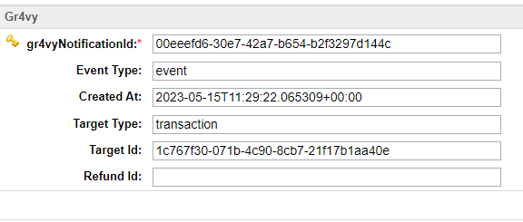

# Backoffice transactions

The cartridge has implementation for the following API methods – Capture, Refund and Void. They are optional and requires custom integration. The implementation is available in script **gr4vy*TransactionHelper.js*** in path ***int_gr4vy/cartridge/scripts/helpers/***

A sample test page to check back-office functionality is provided in int_gr4vy_test cartridge. This can be accessed by opening the Gr4vyTransactionTest-Test controller provided.

An example for Refarch site - <https://sandboxid.dx.commercecloud.salesforce.com/on/demandware.store/Sites-RefArch-Site/en_US/Gr4vyTransactionTest-Test>

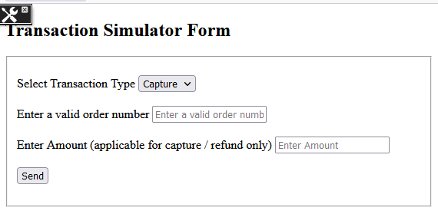

### Capture

The implementation supports full capture only. The function ***TransactionHelper.initiateCaptureRequest*** has the code required to handle capture requests. The function accepts the order number and the amount to be captured as arguments.

The function returns the below error codes:

|  |  |  |
| --- | --- | --- |
| **Error Code** | **Reason** | **Handling Error** |
| UNABLE_TO_FIND_ORDER | Returned when not able to find an order corresponding to the order number passed in the argument. | Retry the operation with correct order number |
| GR4VY_CAPTURE_ERROR | Returned in one of the following scenarios:   * Invalid Capture Amount – amount to be captured exceeds order total plus already captured amount. * Gr4vy Service unavailable * Gr4vy Service returned error response | Check the error log and Gr4vy service logs and take appropriate action. |
| UNABLE_TO_FIND_TRANSACTION | Returned when there is no transaction ID associated with the order | Manually capture the payment via Gr4vy console |
| GENERAL_CAPTURE_ERROR | Returned in case of any exceptions other than above errors | Check the error log and Gr4vy service logs and take appropriate action. |

### Refund

The implementation supports full refund and partial refunds. The function ***TransactionHelper.initiateRefundRequest*** has the code required to handle refund requests. The function accepts the order number and the amount to be refunded as arguments.

The function returns the below error codes:

|  |  |  |
| --- | --- | --- |
| **Error Code** | **Reason** | **Handling Error** |
| UNABLE_TO_FIND_ORDER | Returned when not able to find an order corresponding to the order number passed in the argument. | Retry the operation with correct order number |
| GR4VY_REFUND_ERROR | Returned in one of the following scenarios:   * Invalid refund amount – amount to be refunded exceeds order total plus already refunded amount. * GR4VY Service unavailable * GR4VY Service returned error response | Check the error log and GR4VY service logs and take appropriate action. |
| UNABLE_TO_FIND_TRANSACTION | Returned when there is no transaction ID associated with the order | Manually refund the payment via Gr4vy console |
| GENERAL_REFUND_ERROR | Returned in case of any exceptions other than above errors | Check the error log and service logs and take appropriate action. |

### Void

The implementation supports making the transaction fully void. The function ***TransactionHelper.initiateVoidRequest*** has the code required to handle void requests. The function accepts the order number as argument.

The function returns the below error codes:

|  |  |  |
| --- | --- | --- |
| **Error Code** | **Reason** | **Handling Error** |
| UNABLE_TO_FIND_ORDER | Returned when not able to find an order corresponding to the order number passed in the argument. | Retry the operation with correct order number |
| GR4VY_VOID_ERROR | Returned in one of the following scenarios:   * Invalid void amount * GR4VY Service unavailable * GR4VY Service returned error response | Check the error log and GR4VY service logs and take appropriate action. |
| UNABLE_TO_FIND_TRANSACTION | Returned when there is no transaction ID associated with the order | Manually refund the payment via Gr4vy console |
| GENERAL_VOID_ERROR | Returned in case of any exceptions other than above errors | Check the error log and Gr4vy service logs and take appropriate action. |

# Testing

Sample checkout with Gr4vy embed is shown below.

## Proceed to Checkout as Guest and Enter Shipping Information

Add a product to cart, proceed to checkout, enter a test email ID, and click on “Continue as guest” button. For testing purpose, we will be using the following customer address and personal details.

|  |  |
| --- | --- |
| First Name | Test Name |
| Last Name | Test |
| Address 1 | Test Address 1 |
| Address 2 | Test Address 2 |
| Country | United States |
| State | Mississippi |
| City | Greenwood |
| Zip Code | 38930-5244 |
| Phone Number | 9876543210 |
| Email | Test email ID |

Fill out shipping address and select any shipping method. For the test, we are using Ground.

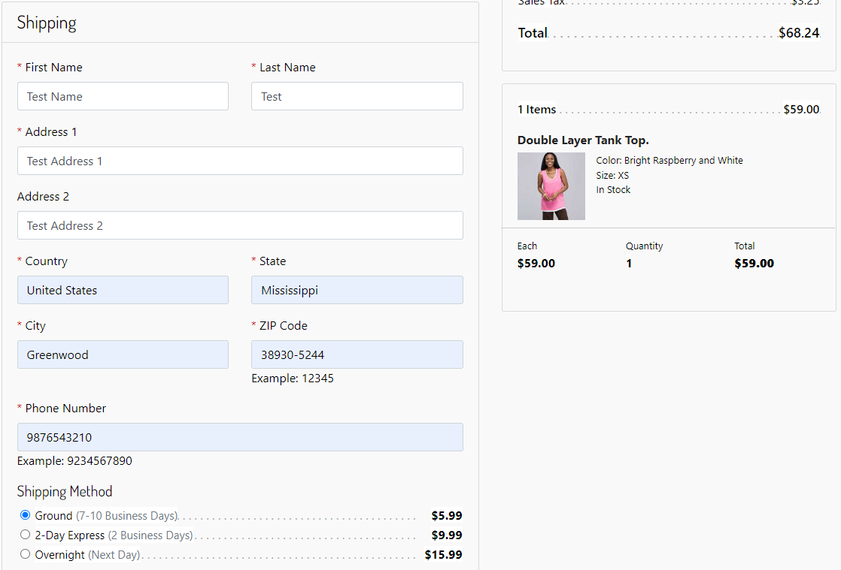

When done, click “Next: Payment”.

## Enter Billing Information and Payment Details

On the billing step, if everything has been configured correctly, Gr4vy should appear as the sole payment method.

Fill out billing details and payment information.

## Placing Order

After filling out billing details and payment information, click on ‘Place Order’. The Gr4vy embed plugin will start processing the payment.

Attaching example screen for PayPal payment.

Once Payment is successfully completed the customer will be shown the order confirmation screen with order details.

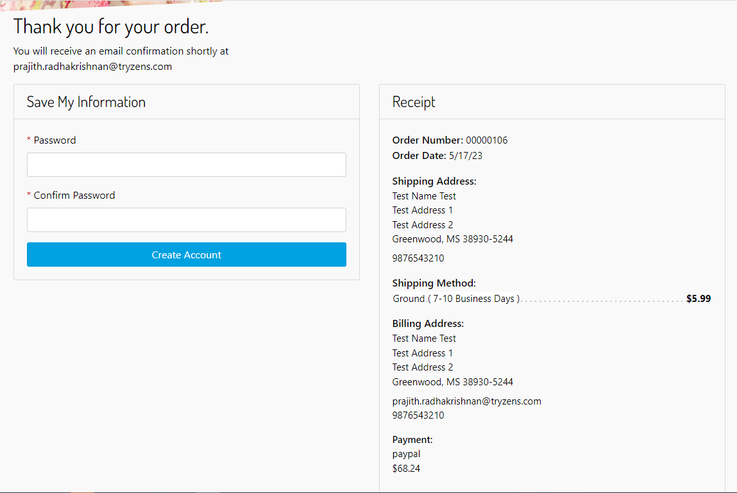

## Confirmation Email

Once the order is placed successfully, a confirmation email will be generated to the email used to do the purchase.

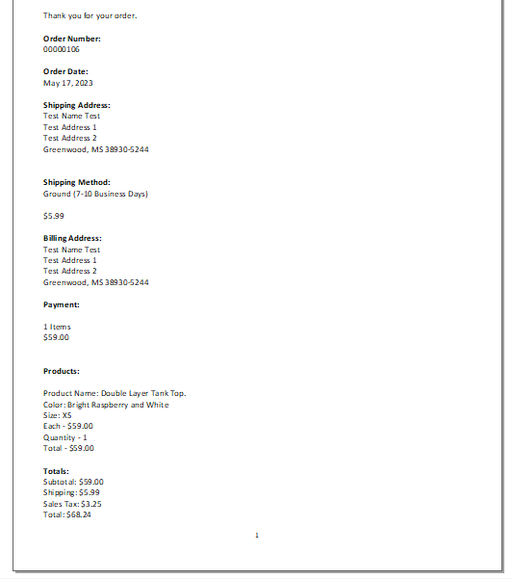

## Check Order in Business Manager

Last, we visit the Order in Business Manager. From “Merchant Tools”, select “Orders”. Type the order number in the search box and click “Find”. Click on the order number.

On the “Attributes” tab, following transaction details returned from Gr4vy are displayed - Gr4vy Buyer ID, Gr4vy Payment Transaction Id, Gr4vy Payment Service Name, Gr4vy Transaction Amount, Gr4vy Transaction Details, Gr4vy Transaction Status

Click on the “Payment” tab. Here we can see the payment method and scheme used for paying the current order. In addition to that, we will be seeing the “Transaction ID”.

## Visit Gr4vy Dashboard to Confirm Order

Once logged into the Gr4vy customer sandbox account, details of the order can be seen.

# Operations, Maintenance

## Data Storage

### Custom Cache

The Gr4vy integration leverages the Custom Cache concept within Salesforce Commerce Cloud to retrieve the configuration data efficiently.

For merchants who have disabled custom cache within Business Manager, the configuration data would be read directly from the custom object. This will not affect the functionality the performance will be slightly lower compared to using custom cache.

|  |  |
| --- | --- |
| **Cache Id** | **Details** |
| JWTTokenHeader | Used for caching custom site preferences - Gr4vy Private Key and Gr4vy PEM file thumbprint |
| gr4vyPreferences | Used for caching custom site preferences in Gr4vy and Gr4vyTheme groups – but excluding Gr4vy Private Key and Gr4vy PEM file thumbprint |

## Availability

In case of problems with the connection to Gr4vy please contact the Gr4vy support department.

Please supply as much information as possible (Merchant account, time, order number, Gr4vy ID etc.).

## Failover / Recovery Process

In case the Gr4vy service is unavailable, the user will not be able to checkout using Gr4vy payment methods.

The service availability can be tracked in SFCC using the Service Status.

## Support

In case of problems with the integration, missing features, etc. please contact the Gr4vy support department or your Gr4vy account manager.

# Appendix

## System Extensions

In addition to the changes mentioned above, the below system extensions were done as part of the cartridge.

### Basket

|  |  |
| --- | --- |
| **Name** | **Purpose** |
| Gr4vy Buyer ID | The buyer id created by Gr4vy for each customer |
| gr4vyTotalGrossPrice | Last Total Gross Price calculated and stored in Gr4vy token. |

### Order

|  |  |
| --- | --- |
| **Name** | **Purpose** |
| gr4vyBuyerId | The buyer id created by Gr4vy for each customer |
| gr4vyPaymentTransactionId | Indicates if the payment method is synchronous or asynchronous |
| gr4vyPaymentServiceName | Payment service used for transaction – Paypal/ Credit Card etc. |
| gr4vyTransactionAmount | Transaction amount returned from Gr4vy |
| gr4vyTransactionDetails | The transaction details object returned from Gr4vy |
| gr4vyTransactionStatus | Array of payment transaction status returned from Gr4vy - capture_succeeded / authorization_failed etc. |

### Profile

|  |  |
| --- | --- |
| **Name** | **Purpose** |
| gr4vyBuyerId | The buyer id created by Gr4vy for each customer |

### OrderPaymentInstrument

|  |  |
| --- | --- |
| **Name** | **Purpose** |
| gr4vyPaymentMethod | Payment method used for transaction – Paypal/ Credit Card etc. |
| gr4vyPaymentMethodScheme | Payment method scheme used for transaction |